Assignment: Working with Linux

# Installation/Configuring Linux

* Execute the Oracle VM Virtual Box installable ‘VirtualBox-4.3.28-100309-Win.exe’
* Run the desktop icon ‘Oracle VM VirtualBox’.
* Create a new virtual machine. Specify memory as 2042 MB.
* Now open the ‘Settings’ window. Go to Storage > Controller: IDE > CD/DVD Drive > Select the Ubuntu iso file shared with you i.e. ‘ubuntu-14.04-desktop-amd64.iso’
* Start the created virtual machine.
* Choose ‘Install Ubuntu’ option.
* In order to close the virtual machine, select Machine > Close… > Save the machine state.

**Assignment 1 (Simple BASH commands):**

**Try following on linux terminal:**  
  
$ echo hello world

Displays the text.

  
$ passwd

Helps the user to change their password.

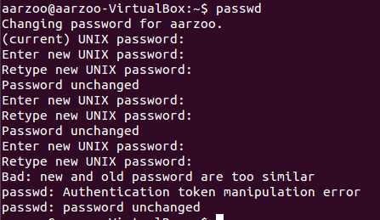

$ date

Displays the current system date



$ hostname

Displays the name of the host(person’s account) working on Linux



$ arch

Describes the architecture the system is based on.



$ uname -a

UNAME: Displays the system information

OPTION -a: prints all information in a following order.



$ dmesg | more(you may need to press q to quit)

Displays or controls the kernel ring buffer( a memory buffer created by the kernel at boot in which to store log data it generates as soon as you get past the bootloader phase).

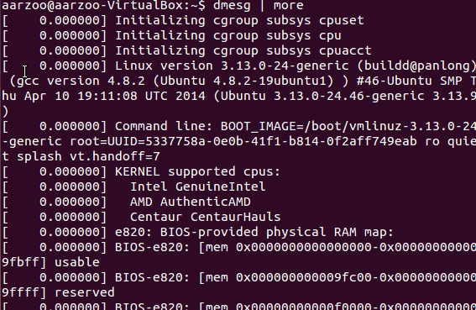

$ uptime

Tell how long the system has been running.



$ who am i

Print effective username of being ran whoami.

$ who

Print information about users who are currently logged in.



$ id

Prints user and group ids.

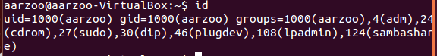

$ last

Displays a list of users log in and out.

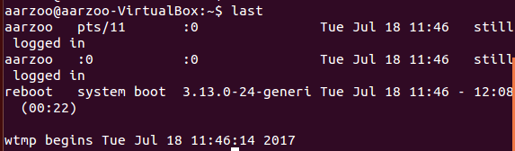

$ finger

The **finger** displays information about the system users.

$ w

Shows who is logged on and what they are doing.

$ top (you may need to press q to quit)

Display linux processes.

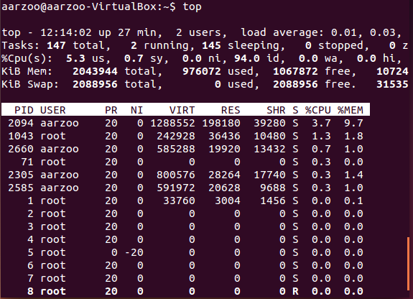

$ echo $SHELL

 shows the value of the [SHELL environment variable](http://pubs.opengroup.org/onlinepubs/009695399/basedefs/xbd_chap08.html#tag_08_03). This is a user configuration, which you can set to the path to your favorite interactive shell.



$ echo {con,pre}{sent,fer}{s,ed}

Possible combination of words created from parts given.



$ man "automatic door"

Only the in-built functions fed in library are detected



$ man ls (you may need to press q to quit)

Gives description of the command.

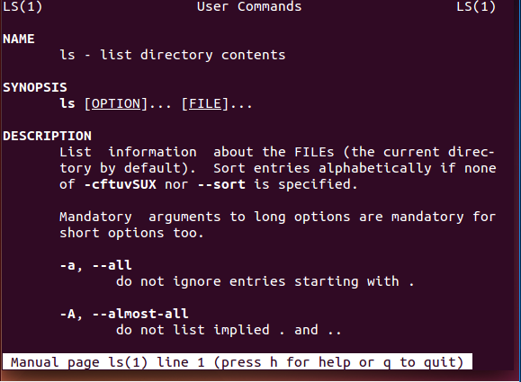

$ man who (you may need to press q to quit)

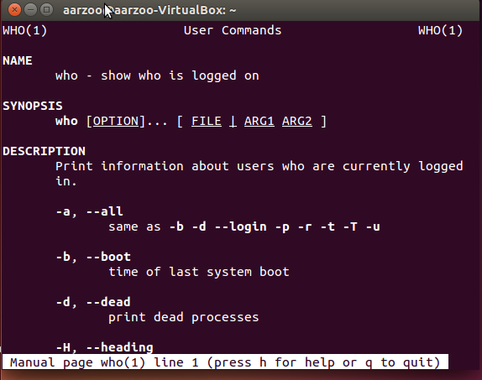

$ who can tell me why i got license

Only the in-built functions fed in library are detected

$ lost

If you type a command with a spelling mistake, you are suggested with the options of the right spelled commands.

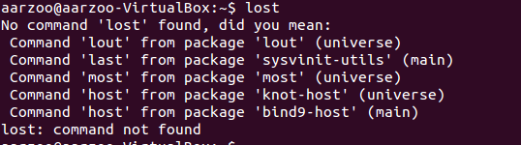

$ clear

Clears the terminal screen.

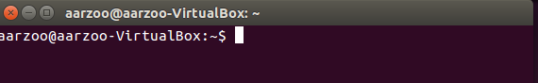

$ cal 2000

Displays the calendar for the given year.

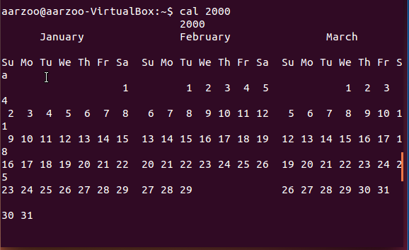  
$ cal 9 1752(do you notice anything unusual?)

Displays a specific month from the year.

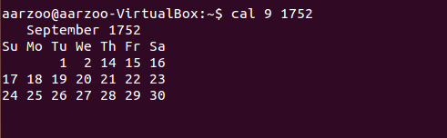

$ bc -l(type quit or press Ctrl-d to quit)

Displays the software information.

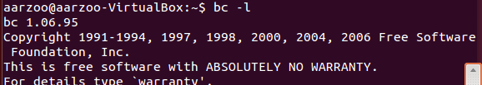  
$ echo 5+4 | bc -l

Echo displays just the text and nothing else. No command is displayed.



$ yes please(you may need to press Ctrl-c to quit)

Displays the word mentioned in unending loop.

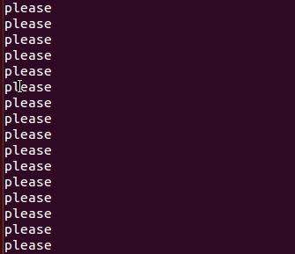

$ time sleep 5

The system responds after 5 seconds.

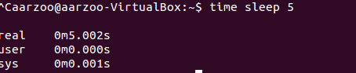

$ history

Displays the history of all the commands tried in terminal.

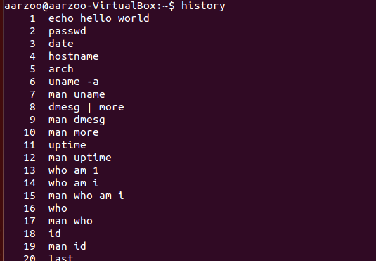

**Assignment 2 (Simple operations on file & directory):**

1. Enter cd ~. Using the picture below, create two subdirectories named india and China—note China starts with a capital letter and india does not.



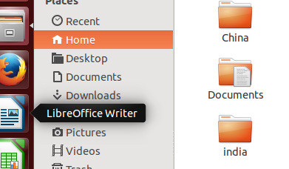

1. Under india and China, create three more subdirectories each – clothing, food, and sports.

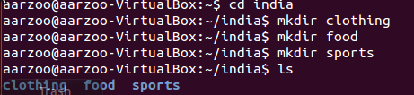

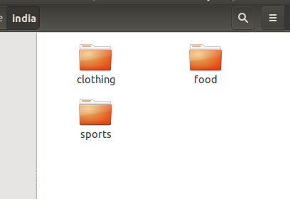

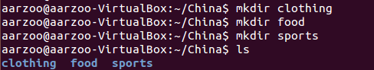

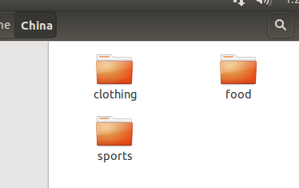

1. Use the Internet and lookup a few facts about clothing in India. Use the editor to create a file and write what you found in the editor. Save the file. Did you create it in the correct subdirectory? If not, move the file to the clothing subdirectory under india.





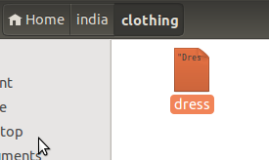

1. In the correct subdirectory, use the editor to create a file and write about your favorite Indian food. Save the file. Make sure it is in the correct subdirectory!

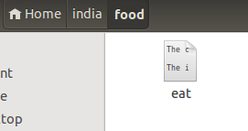

1. Use the Internet to lookup a few facts about sports in China. In the Sports subdirectory under india, use the editor to create a file that describes what you found about sports in China. Yes, this is the incorrect place, but it gives you a chance to practice moving in the next step!

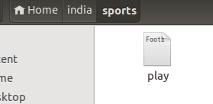

1. Move the file you just created from the sports subdirectory under india to the sports subdirectory under china.



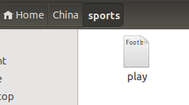

1. Copy the file from the clothing subdirectory under india to the clothing subdirectory under china.



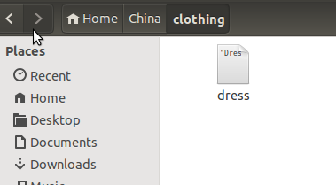

1. Copy the file from the food subdirectory under india to the food subdirectory under China. Edit the new file to reflect your favorite meal that could be cooked in China.



1. Delete the subdirectory clothing under india.



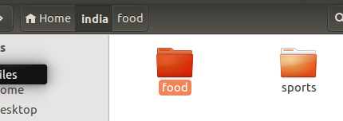

**Assignment 3 (vi Editor):**

1. Create a new document ‘history_linux.txt’ & type the following contents:

You might be suprised to discover that Linux has been around in it's current form sinc the early 90's but the fondations go back much longer.

Late 1960's - Unix is developed developed and released in 1970's. It is widely adopted in business and academic circles.



1. Save & close the file.
2. Reopen the file in vi editor.



1. Go to the end of the document and type in the following paragraph:  
   1983 - a programmer Richard Stallman creates the GNU Project. It is an attempt at creating a Unix type operating system but composed of entirely free software.

Write using “i”

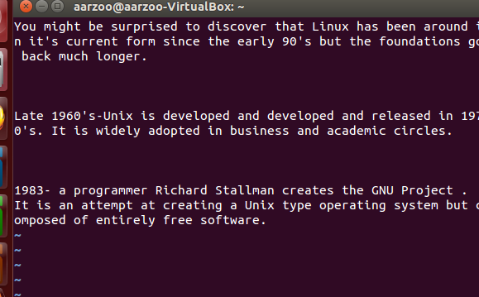

1. Correct  the three  spelling errors and  remove the extra word "developed".

Using “r” to replace current letter.

1. Add the words "Here is year wise Linux history!" to the end of the first paragraph.
2. Delete the words "developed and" from second paragraph.

Using “delete” to delete.

1. Replace all occurrences of "is" with "was".

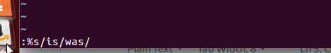

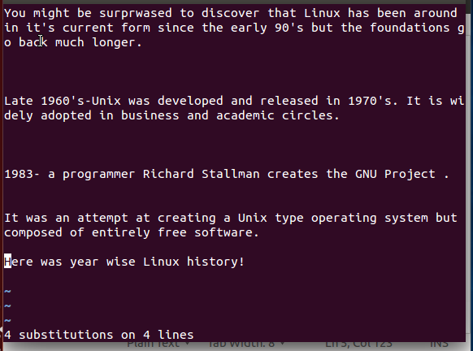

EXPLANATION:

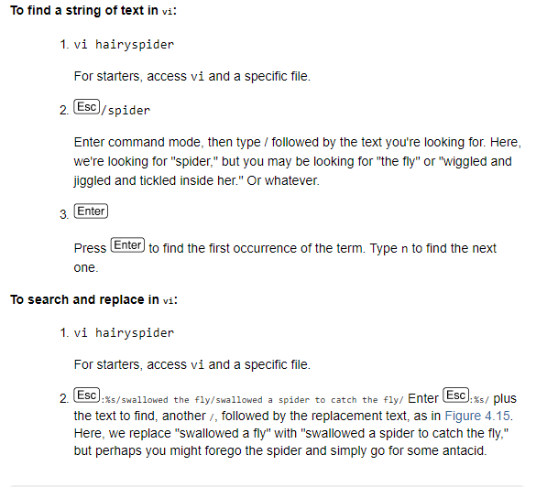

1. Swap the second & third paragraphs.

Use “dd” to delete a para and “p” to paste down the para.

1. Save the file and quit.

Use “esc:w” to save a file and “esc:q” for quit or “esc:wq”

**Assignment 4 (File Permissions):**

1. Create a group xoriant.





1. Create 2 users tom & jerry inside ‘xoriant’ with the home directories /home/tom & /home/jerry



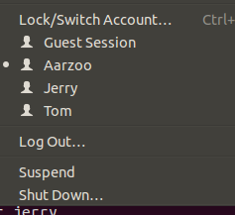

1. In tom’s home directory, create a directory ‘tom_docs’.

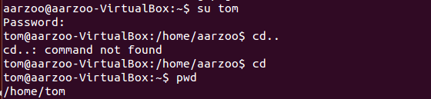



1. In jerry’s home directory, create a directory ‘jerry_docs’.

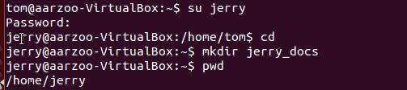

1. Login as tom or jerry as per requirement using ‘su’ command.



1. Create a file inside each directory i.e. ‘tom_resume.txt’ & ‘jerry_resume.txt’.

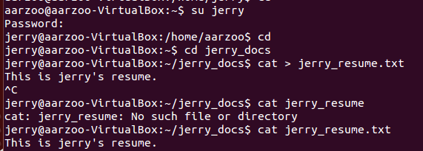

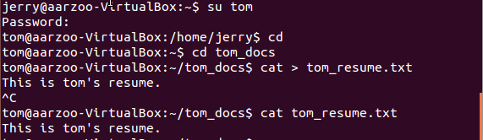

1. Add some contents into the files.

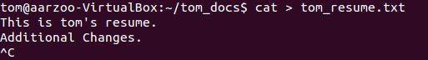

1. Change the permission of tom_resume.txt to writable at user level & group level.’



1. Change user to jerry & try to update tom_resume.txt using vi editor.



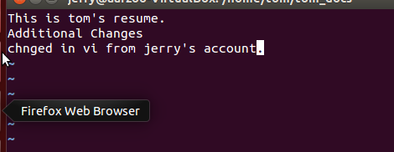

1. Similarly apply writable permission at jerry_resume.txt at user & group level. Try to update jerry_resume.txt through tom’s login.



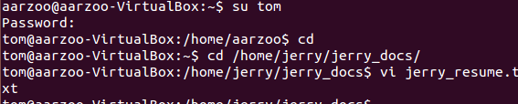

1. Make tom_docs writable at group level. Add sticky bit to tom_docs directory. Try to delete this directory using jerry’s login. It should not allow.

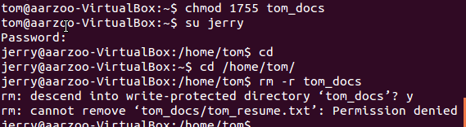

**Assignment 5 (Process related information):**

1. Start an editor ‘gedit’.

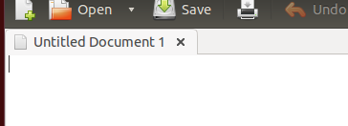

1. Display the information about all processes running on your machine.

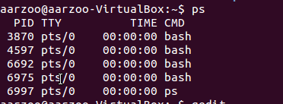

1. Find the process id of gedit process.

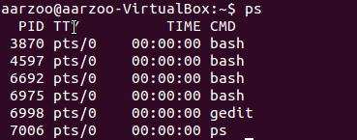

1. Stop gedit process.



1. Again start gedit.
2. Find whether gedit is running or not.
3. Display the process tree.ps

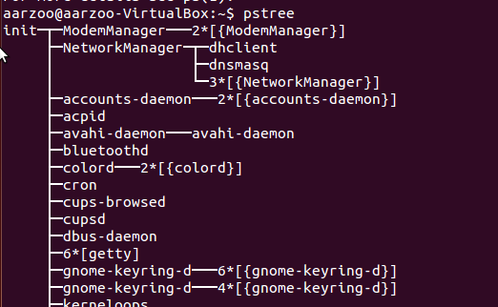

1. Display currently running process along with memory & CPU usage.

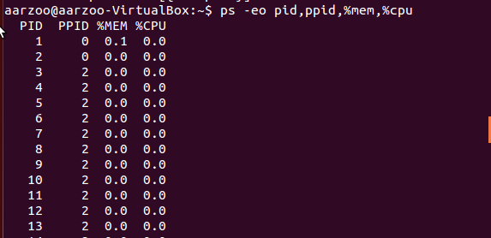

Gedit’s info

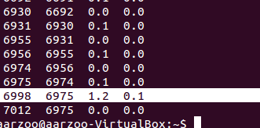

**Assignment 6 (Inter machine files transfer):**

1. Transfer a file from one to another machine.
2. Transfer a directory including all its contents from one to another machine.